1.



By Fermat's Little Theorem, the fact that g is a primitive root implies that  divides, so we have 

2.

Python3:

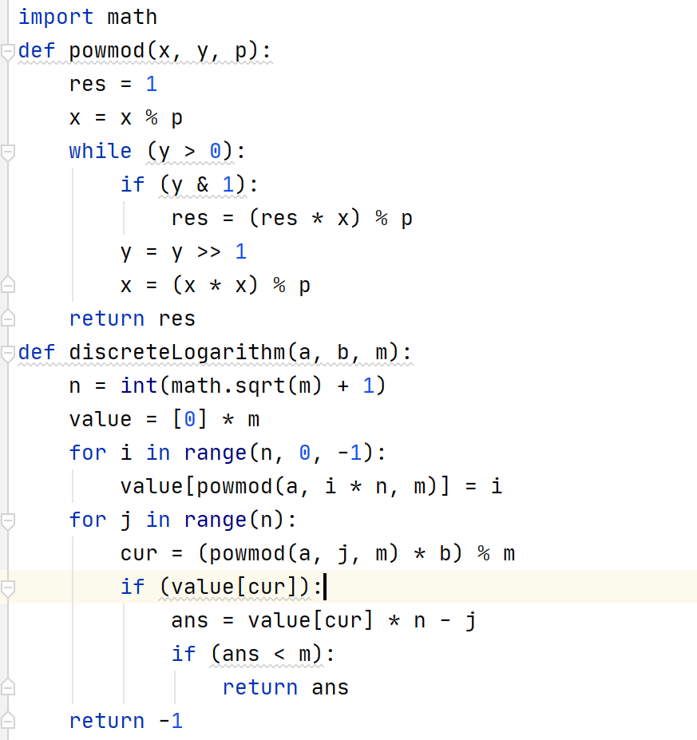

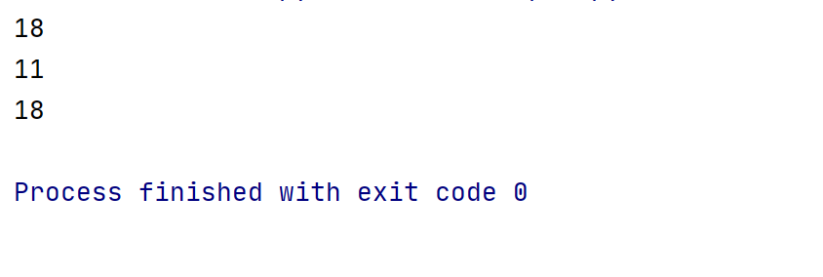

(a)18

(b)11

(c)18

3.

No, S3 is not commutative group.

4.



Q is a prime order b=1 or order b=q, but order b can’t be 1, so order b=q.